1. Open Ozene Widget Framework, and click icon  in the left-top corner. Then you will have a screen come up like this:

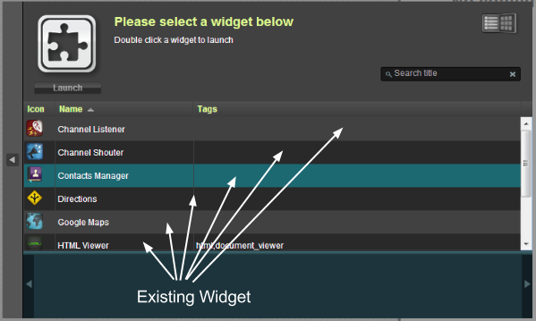

2. Choose the existing widget in the list and double click.